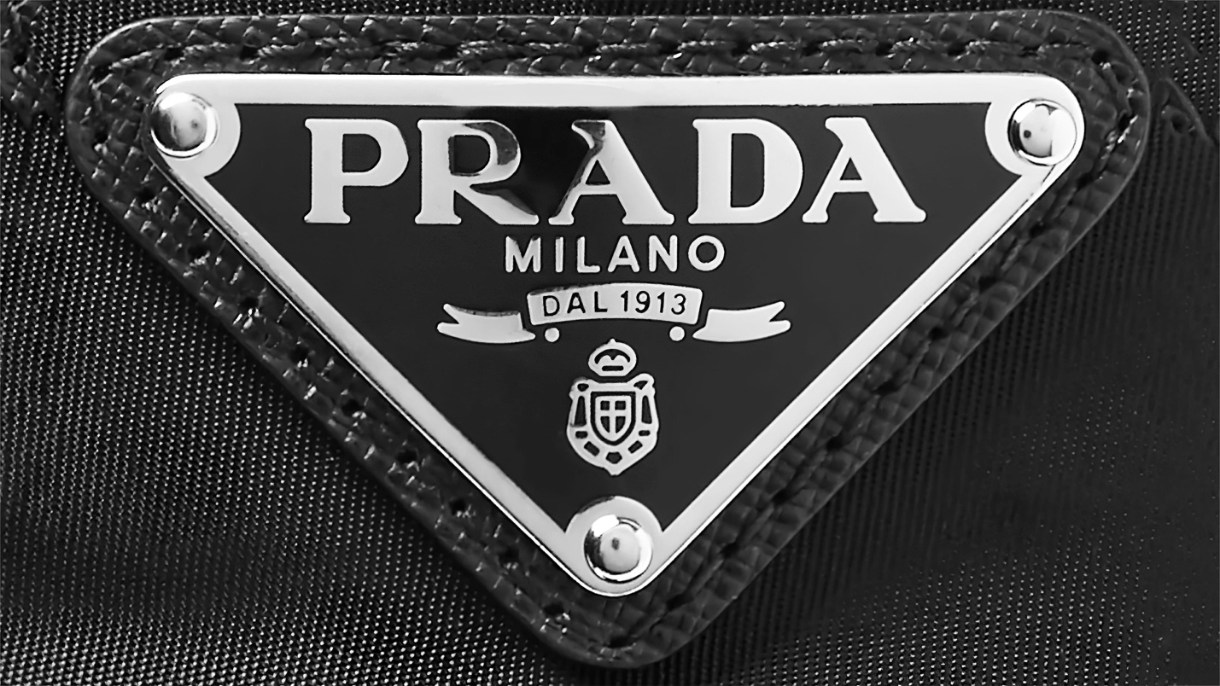

Dark Chrome Symbole Sunglasses

**$ 250**

Metal sunglasses characterized by the contemporary touch of the flat geometric front combined with straight temples. The double bridge is accented with a metal insert that reinterprets the historic triangle logo of the maison.

